OFFICE 365
FOR THE JOB SEARCH
A Practical, Illustrated Guide to Word, Excel, PowerPoint,
Outlook, Teams, OneDrive & OneNote
A beginner-friendly manual built for job seekers
who need real, workplace-ready computer skills.

How to Use This Book
This manual is built around one goal: getting you comfortable and confident using Microsoft Office 365 for the tasks that come up most in a job search and in almost any office job — writing documents, tracking information, presenting yourself, communicating professionally, meeting online, and keeping your files organized.
Each chapter covers one application and follows the same pattern:
- Why it matters for your job search — the real situations where you'll use this app.
- A labeled illustration of the interface — so the screen doesn't feel like a wall of unfamiliar buttons.
- Step-by-step instructions for the tasks you'll use most.
- Tips & Tricks — small things that save real time once you know them.
- Common Mistakes — the errors almost everyone makes at first, so you can skip them.
- A Practice exercise — a small, real task to do on your own computer before moving on.

Before You Start
- You'll get the most out of this book if you work at a computer while reading it — read a step, then do it.
- Office 365 looks almost identical whether you're using it on Windows, Mac, or in a web browser at office.com. The screenshots in this book use simplified diagrams rather than real screenshots so the labels stay easy to read, but the buttons and menus you'll see match what's described here.
- You don't need to buy anything extra. If your computer doesn't have Office installed, you can use the free web versions at office.com with any Microsoft account (the same kind used for Outlook.com or Xbox).
- It's fine to skip around. If you already know Word but have never used Excel, jump straight to Chapter 3.
ℹ NOTE
Every chapter builds a piece of a real “Job Search Toolkit.” By the end of the book (Chapter 8), you'll have a resume, a cover letter template, a job application tracker, a short portfolio deck, a professional email setup, and an organized set of folders and notes — all built by you, while learning.

Quick Reference: Which App Do I Use For...?
If you already know roughly what you want to do and just need to know where to go, start here. Otherwise, read the chapters in order.
I want to... | Use this app
Write or format my resume or a cover letter | Word (Ch. 2)
Track which jobs I've applied to, or build a budget | Excel (Ch. 3)
Build a short slide deck to show an interviewer | PowerPoint (Ch. 4)
Email an application, or schedule an interview | Outlook (Ch. 5)
Join or prepare for a video interview | Teams (Ch. 6)
Back up my files, or keep them organized | OneDrive (Ch. 7)
Take notes for interview prep or company research | OneNote (Ch. 7)

Contents
Chapter 1 Office 365 Basics
Chapter 2 Microsoft Word
Chapter 3 Microsoft Excel
Chapter 4 Microsoft PowerPoint
Chapter 5 Microsoft Outlook
Chapter 6 Microsoft Teams
Chapter 7 OneDrive & OneNote
Chapter 8 Your Digital Job Search Toolkit
Appendix A Keyboard Shortcuts Cheat Sheet
Appendix B Glossary of Terms
Appendix C Troubleshooting Common Problems

Introduction: Why These Skills Matter
Job postings today routinely list “proficient in Microsoft Office” as a requirement — even for roles that have nothing to do with computers on the surface. That's because Word, Excel, Outlook, and the rest have become the shared language of office work almost everywhere: hospitals, schools, warehouses, retail head offices, nonprofits, and government agencies all run on the same handful of applications.
That's good news for you. Unlike many job skills that take years to build, Office 365 skills can be learned in weeks through steady, hands-on practice — and they transfer to almost any employer, in almost any industry. The same resume-building skill in Word works whether you're applying to a hospital, a bank, or a construction company.

What This Book Assumes
- No prior computer experience is assumed beyond being able to turn on a computer and use a mouse or trackpad.
- You have (or can create for free) a Microsoft account and access to a computer, tablet, or library computer with internet access.
- You're motivated by a real goal — usually, finding or improving a job — which is exactly the lens this book uses throughout.

A Note on Confidence
Almost everyone who has ever felt intimidated by “computer stuff” has the same experience once they sit down and actually try it: the ribbon, the menus, and the buttons are far more forgiving than they look. Nearly every action in Office can be undone with Ctrl+Z. You cannot break the computer by clicking the wrong button. Treat each chapter as a place to experiment freely.
CHAPTER 1

Office 365 Basics
The concepts and screen elements every Office app shares

What Is Office 365?
Office 365 (now often called “Microsoft 365”) is a subscription bundle of Microsoft's office software, delivered two ways:
- Desktop apps — Word, Excel, PowerPoint, Outlook, and others installed on your computer, working even without internet.
- Web apps — the same programs running in a browser at office.com, free with any Microsoft account, no installation needed.
Both versions save your work automatically to OneDrive, Microsoft's cloud storage, so your files follow you between your laptop, your phone, and any library or shared computer you sign into.

Signing In
- Go to office.com (or open an installed Office app).
- Choose Sign In, and enter your Microsoft account email and password. If you don't have one, choose Create free account — any email address works.
- Once signed in, you'll see the Office “waffle” menu (a 3×3 grid of squares) in the top-left corner of any Microsoft page — click it any time to jump between Word, Excel, Outlook, and the rest.

Elements Every Office App Shares
Once you learn these, every Office app feels familiar:
- The Ribbon — the strip of tabs (Home, Insert, Layout...) and buttons across the top. Tabs group related tools; the buttons underneath each tab change depending on which one is selected.
- The Quick Access Toolbar — tiny icons above or below the ribbon (Save, Undo, Redo) always visible no matter which tab you're on.
- AutoSave / Save — when a file is stored in OneDrive, Office saves your changes automatically every few seconds. A local file still needs Ctrl+S (Windows) or Cmd+S (Mac) from time to time.
- File > Save As / Download — use this to save a copy, change the file format (like turning a Word doc into a PDF), or save to a different folder.

File Types You'll See
Shortcut | What it does
.docx | A Word document (resume, cover letter, letters)
.xlsx | An Excel spreadsheet (budgets, trackers, lists)
.pptx | A PowerPoint presentation (slide decks)
.pdf | A fixed, uneditable format — the safest way to send a finished resume so formatting never shifts on the recruiter's screen

💡 TIP
Always send your finished resume and cover letter as a PDF, not a .docx. A PDF looks identical on every device; a Word file can shift fonts, spacing, or page breaks depending on what's installed on the reader's computer.

Naming Your Files Well
A recruiter may see hundreds of files named “Resume.docx.” Make yours easy to find and clearly yours:
- FirstName_LastName_Resume.pdf
- FirstName_LastName_CoverLetter_CompanyName.pdf
- Avoid spaces at the start/end of filenames and avoid symbols like / \ : * ? " < > |
✏️ PRACTICE: Get comfortable in the neighborhood
- Sign in at office.com with a Microsoft account (create one if needed).
- Open Word, Excel, and PowerPoint once each, just to see the waffle menu and ribbon in each.
- Create a new blank Word document, type your name, and save it as YourName_Practice.docx.
CHAPTER 2

Microsoft Word
Resumes, cover letters, and any document that needs to look professional

Why It Matters for Your Job Search
Word is where your resume, cover letter, and reference list get built. A clean, well-formatted Word document is often the very first impression a hiring manager forms of you — before they've read a single word.

Tour the Interface
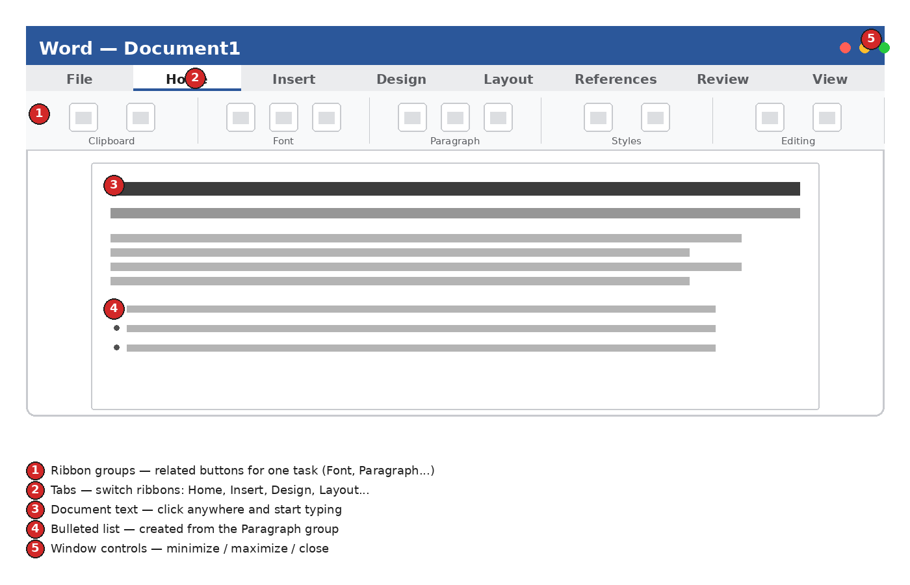
Figure 2.1 — The Word ribbon interface

Core Skills

2.1 Starting a Document
- Open Word and choose Blank document, or pick a Resume template from the template gallery.
- Click anywhere in the page and start typing.
- Save immediately: File > Save As, choose OneDrive, and name the file clearly (see Chapter 1).

2.2 Formatting Text
Select text first (click and drag, or double-click a word) before applying formatting — Word only changes what's selected.
- Bold / Italic / Underline — in the Font group of the Home tab, or Ctrl+B / Ctrl+I / Ctrl+U.
- Font & size — dropdown menus at the top-left of the Font group. Stick to one or two fonts per document.
- Text color / highlight — use sparingly in a resume; color doesn't always survive printing or PDF conversion cleanly.

2.3 Paragraphs, Spacing & Alignment
- Alignment (left / center / right / justify) — Paragraph group, Home tab.
- Line & paragraph spacing — the icon with horizontal lines and up/down arrows; tighter spacing (1.0 or 1.08) keeps a one-page resume from spilling to page two.
- Bulleted and numbered lists — the list icons in the Paragraph group; describe achievements as bullets, not paragraphs.

2.4 Styles — the Fast Way to Consistent Formatting
The Styles gallery (Home tab, right side) lets you apply a consistent heading look with one click, instead of manually bolding and resizing every section title. Click into a line, then click a style like “Heading 2” to format it instantly — and every heading using that style updates together if you change your mind later.

2.5 Page Setup
- Margins — Layout tab > Margins. “Narrow” (0.5in) buys extra room on a tight one-page resume.
- Page size — Layout tab > Size (Letter is standard in the US).
- Headers & footers — Insert tab > Header/Footer; useful for adding page numbers to a longer document like a portfolio or report.

2.6 Tables (for clean resume layouts)
Insert tab > Table lets you create an invisible-bordered table to line up a job title on the left with a date on the right — a common resume trick. After inserting, select the table, open the Table Design tab, and set Borders to “No Border” so only the alignment remains, not visible lines.

2.7 Spell Check & Proofing
Word underlines possible spelling errors in red and grammar/style issues in blue. Right-click an underlined word for suggestions, or run a full check via Review tab > Spelling & Grammar. Always proofread a resume yourself too — spell check won't catch a correctly-spelled wrong word (“manger” instead of “manager”).

2.8 Comments & Track Changes (getting feedback)
If a friend, career coach, or job-search mentor is reviewing your resume, ask them to turn on Review tab > Track Changes before editing, and to use New Comment for suggestions. You'll see exactly what changed and can accept or reject each edit individually.

2.9 Saving as PDF
- Go to File > Save a Copy (or Export).
- Choose PDF as the file type.
- Save it with a clear filename (see Chapter 1) and open it once to confirm nothing shifted before sending it anywhere.

Anatomy of a Resume in Word
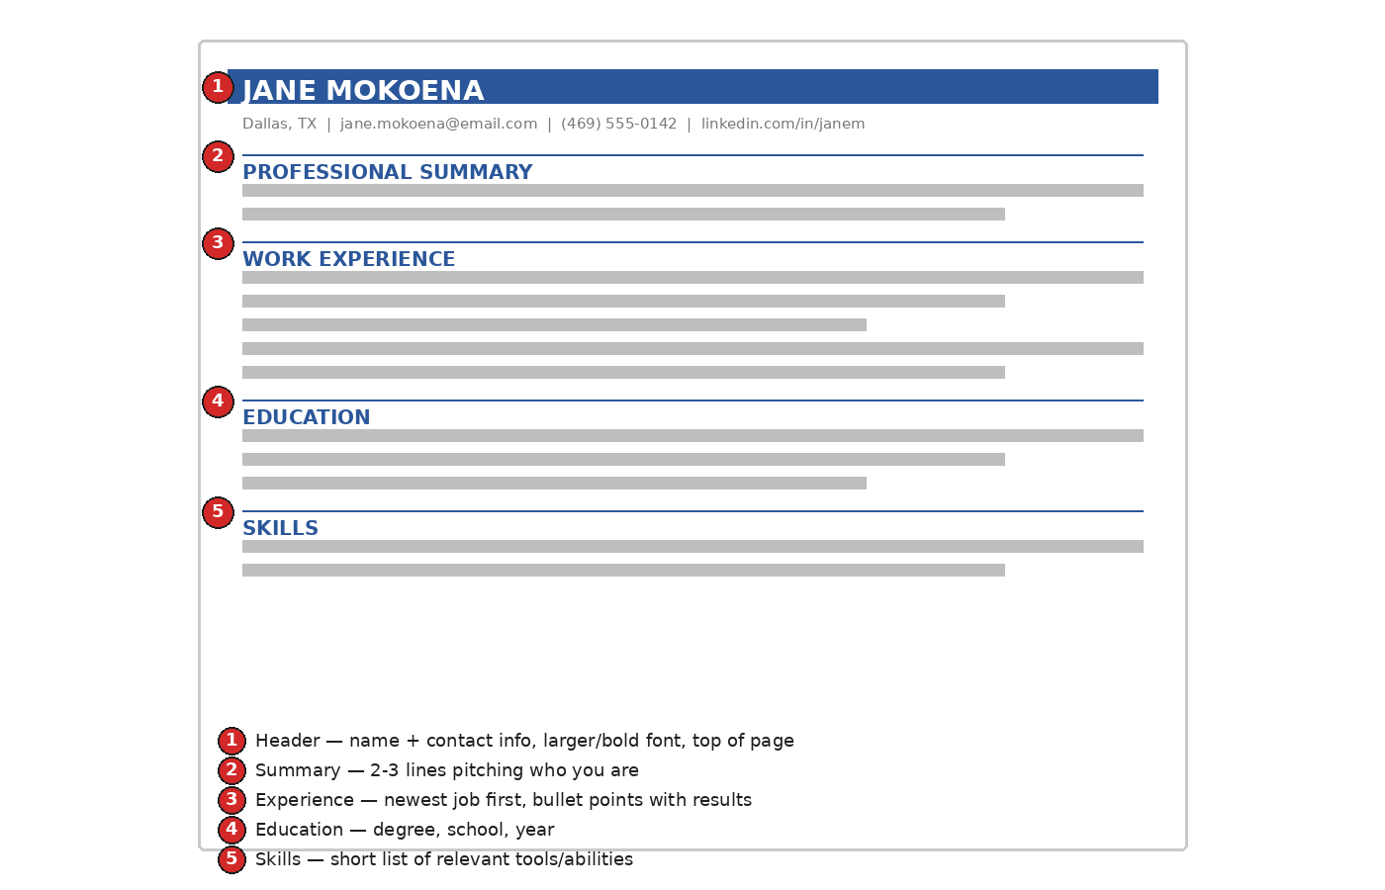
Figure 2.2 — Anatomy of a resume built in Word

Step-by-Step: Build a One-Page Resume
- Open a blank document and set narrow margins (Layout > Margins > Narrow).
- Type your full name at the top, apply Heading 1 style, and center it.
- On the next line, add your city/state, email, and phone number, smaller font, centered.
- Type “PROFESSIONAL SUMMARY,” apply Heading 2 style, and write 2–3 sentences summarizing your experience and goal.
- Add a “WORK EXPERIENCE” heading. For each job: company & job title (bold), dates (right-aligned using a table or tab stop), and 2–4 bullet points describing what you did and achieved.
- Add “EDUCATION” and “SKILLS” headings the same way.
- Read through once for spacing consistency, run Spelling & Grammar check, then save as PDF.
✨ TRICK
Select a bullet point's text and press Ctrl+Shift+C, then click into another line and press Ctrl+Shift+V — this copies just the formatting (Format Painter shortcut), not the text, so every bullet matches perfectly without retyping styles.

Common Mistakes
⚠ COMMON MISTAKE
Using several different fonts, sizes, and bullet styles across one resume. Pick one font (e.g., Calibri or Arial) and one heading style, then apply it everywhere using Styles — consistency reads as professionalism.

⚠ COMMON MISTAKE
Sending the .docx file instead of a PDF, so formatting shifts on the recruiter's screen. Always export and double-check a PDF version before sending.

Keyboard Shortcuts
Shortcut | What it does
Ctrl + S | Save
Ctrl + B / I / U | Bold / Italic / Underline
Ctrl + Z / Y | Undo / Redo
Ctrl + A | Select all text
Ctrl + C / V | Copy / Paste
Ctrl + F | Find text
Ctrl + Home / End | Jump to top / bottom of document
✏️ PRACTICE: Build your resume
- Using the steps above, build a complete one-page resume with your real information.
- Apply Heading styles consistently to all section titles.
- Export it as a PDF named FirstName_LastName_Resume.pdf.

Bonus: Building a Cover Letter
A cover letter uses the same Word skills as a resume, arranged as a short business letter. Here is a complete, adaptable example — copy its structure, then replace the bracketed details with your own:
[Your Name] | [City, State] | [Email] | [Phone]

[Today's Date]

[Hiring Manager's Name, if known]
[Company Name]

Dear [Hiring Manager's Name / Hiring Team],

I am writing to apply for the [Job Title] position at [Company Name], which I found on [where you saw the posting]. With [X years / a strong background] in [relevant field or skill], I am confident I can contribute to your team from day one.

In my most recent role at [Previous Company], I [one specific accomplishment with a result — numbers if you have them]. I also bring [a second relevant strength], which I understand is valuable for this role given [something specific from the job posting].

I would welcome the opportunity to discuss how my background fits your team's needs. Thank you for your time and consideration — I look forward to hearing from you.

Sincerely,
[Your Name]

💡 TIP
Save this letter as a Word template (File > Save As Template, or just keep a master .docx called CoverLetter_Template.docx) and duplicate it for every application — changing the company name, job title, and 2–3 specific details each time is far faster than starting from scratch.
CHAPTER 3

Microsoft Excel
Job trackers, budgets, and any list that needs to calculate something

Why It Matters for Your Job Search
A spreadsheet is the easiest way to stay organized during a job search — tracking which companies you've applied to, on what date, and what happened next. It's also a core workplace skill on its own: most office jobs expect basic comfort with Excel.

Tour the Interface
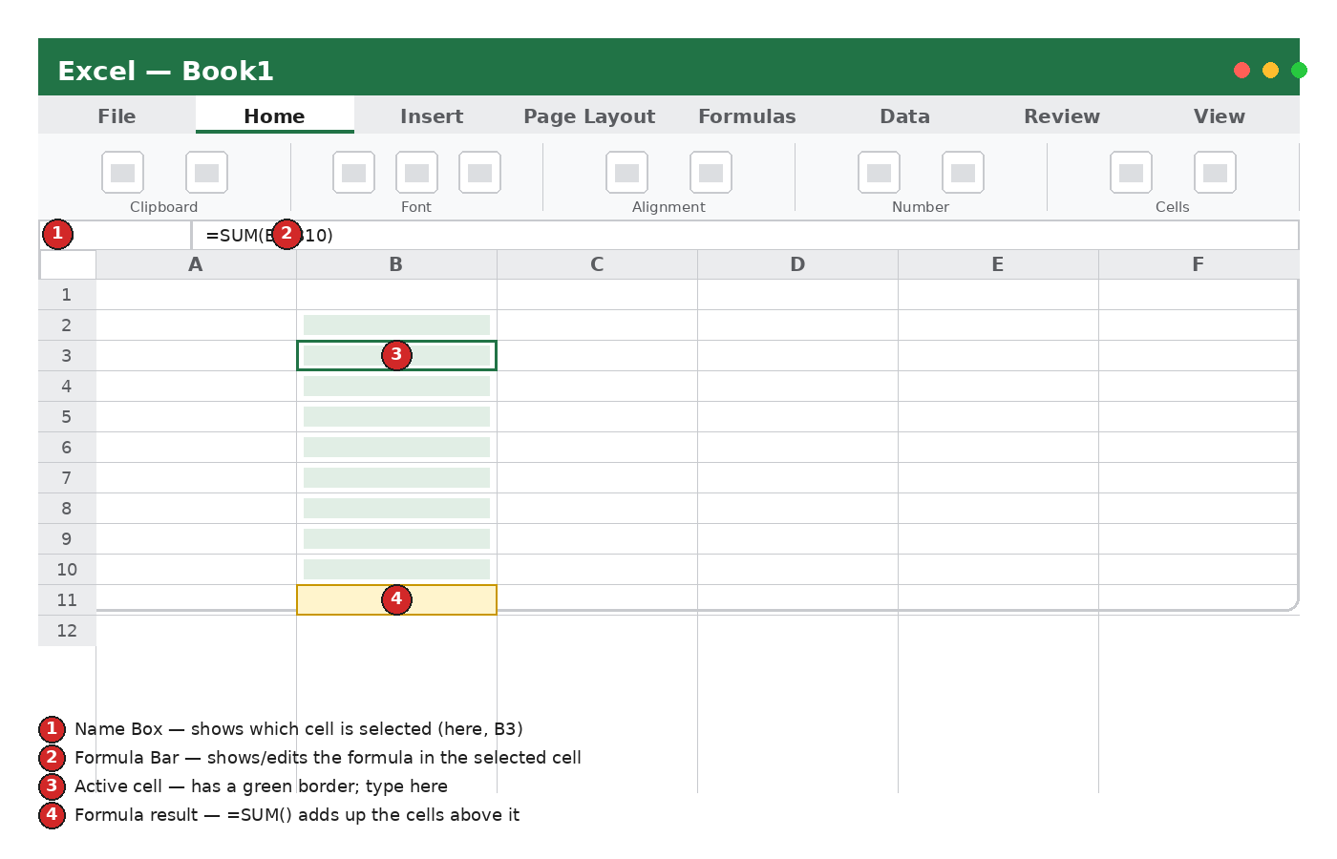
Figure 3.1 — The Excel interface: name box, formula bar, and grid

Core Skills

3.1 The Grid: Rows, Columns, Cells
- Columns are lettered (A, B, C...); rows are numbered (1, 2, 3...).
- A cell's address combines both, e.g. B3 means column B, row 3.
- Click a cell to select it; the Name Box (top-left) confirms which one is active.

3.2 Entering & Editing Data
- Click a cell and type; press Enter to move down, Tab to move right.
- Double-click a cell (or press F2) to edit its existing content instead of replacing it.
- Drag the small square at a cell's bottom-right corner (the “fill handle”) to copy a value or continue a pattern (like dates or numbers) down a column — called AutoFill.

3.3 Basic Formulas
Every formula starts with an equals sign. A few that cover most job-search and budgeting needs:
Shortcut | What it does
=SUM(B2:B10) | Adds every value from B2 through B10
=AVERAGE(B2:B10) | Averages that same range
=COUNT(B2:B10) | Counts how many cells contain numbers
=COUNTA(B2:B10) | Counts how many cells contain anything at all
=TODAY() | Inserts today's date, updating automatically
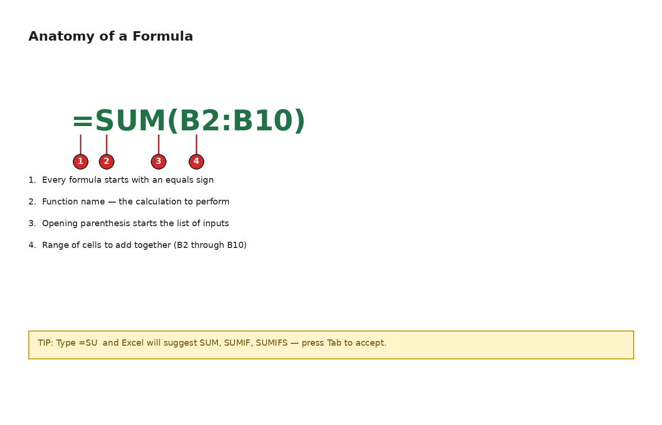
Figure 3.2 — Anatomy of a formula

3.4 Formatting Cells
- Currency / percentage / date formatting — Home tab, Number group.
- Bold headers and light shading on a header row make a sheet far easier to read at a glance.
- Column width — double-click the border between two column letters to auto-fit the widest content.

3.5 Sorting & Filtering
Select your data, then Data tab > Sort to reorder rows (e.g., soonest interview date first), or Data tab > Filter to add dropdown arrows on each header letting you show only rows matching a condition (e.g., only rows where Status = “Interview Scheduled”).

3.6 Conditional Formatting
Home tab > Conditional Formatting can automatically color a cell — for example, turning a Status column green when it says “Offer” and red when it says “Rejected,” so patterns jump out without reading every row.

3.7 A Simple Chart
Select your data, then Insert tab > choose a chart type (a simple bar or pie chart is usually clearest). Excel builds it instantly and lets you drag it anywhere on the sheet.

3.8 Freeze Panes
On a long list, View tab > Freeze Panes > Freeze Top Row keeps your column headers visible while you scroll down hundreds of rows.

Step-by-Step: Build a Job Application Tracker
- Open a blank workbook. In row 1, type headers across columns A–F: Company, Role, Date Applied, Status, Contact, Notes.
- Bold row 1 and add light gray shading (Home > Fill Color) so it stands out as a header.
- Enter a row for each job you apply to as you go.
- Select the Status column and set up Conditional Formatting: green for “Interview,” yellow for “Applied,” red for “Rejected.”
- Select your header row and turn on Data > Filter so you can sort or filter by status any time.
- In a cell below the table, add =COUNTA() on the Company column to see your total applications at a glance.
✨ TRICK
Type Ctrl+; to instantly insert today's date into a cell without typing it — handy for logging the date you applied to each job.

Common Mistakes
⚠ COMMON MISTAKE
Typing numbers as text (e.g., with a stray space or apostrophe) so formulas silently skip them. If a formula result looks wrong, check that the cells being summed are truly numbers — they'll be right-aligned by default when Excel recognizes them as numbers.

⚠ COMMON MISTAKE
Seeing #REF! or #DIV/0! and assuming the spreadsheet is broken. #REF! means a formula points to a cell that was deleted; #DIV/0! means it's dividing by zero or an empty cell. Click the cell and check the formula bar to see exactly what it's referencing.

Keyboard Shortcuts
Shortcut | What it does
Ctrl + Arrow key | Jump to the edge of a block of data
Ctrl + ; | Insert today's date
Alt + = | Auto-sum the selected range
Ctrl + 1 | Open Format Cells
F2 | Edit the active cell
Ctrl + Space / Shift + Space | Select entire column / entire row
✏️ PRACTICE: Build your job tracker
- Create the tracker described above with at least 5 real or practice rows.
- Add conditional formatting to the Status column.
- Add a formula that counts your total applications.

Bonus: Two More Formulas Worth Knowing

IF — Making a Cell Decide
=IF(logical_test, value_if_true, value_if_false) checks a condition and returns one of two results. For example, in a budget tracker, =IF(B2>500, "Over Budget", "OK") looks at cell B2 and labels it automatically.

VLOOKUP — Looking Up Information
=VLOOKUP(value, table_range, column_number, FALSE) searches for a value in the first column of a range and returns a matching value from another column — useful once your job tracker grows large enough that you want to look up a company's contact info by name instead of scrolling to find it.

Bonus: A Simple Budget Tracker
The same skills build a personal budget — useful while job searching on a tight income:
- In a new sheet, list your monthly income sources in column A and amounts in column B.
- Below that, list expenses (rent, phone, transport, groceries) in column A with amounts in column B.
- Add a =SUM() formula to total income, and another to total expenses.
- In a final cell, calculate =[Total Income]-[Total Expenses] to see what's left over.
- Use conditional formatting to turn that final cell red if it's negative.
CHAPTER 4

Microsoft PowerPoint
A short portfolio deck or presentation you can show in an interview

Why It Matters for Your Job Search
Not every job needs a slide deck, but being able to build one confidently is a widely expected office skill — and a short “About Me” or portfolio deck can set you apart in an interview, especially for creative, technical, or client-facing roles.

Tour the Interface
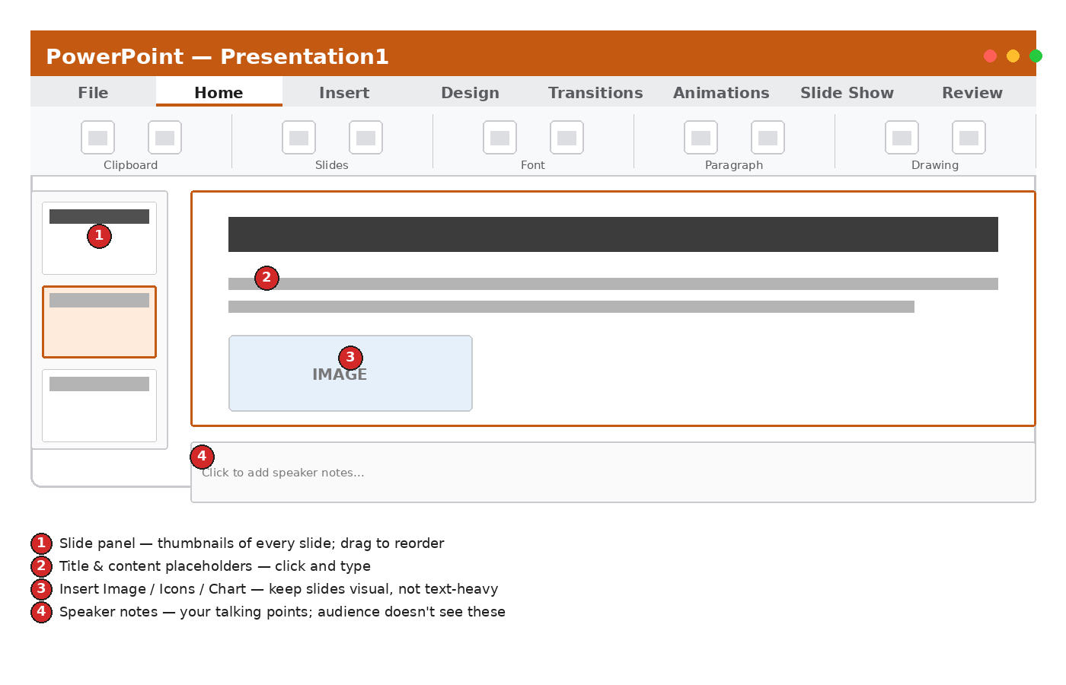
Figure 4.1 — The PowerPoint interface

Core Skills

4.1 Slides & Layouts
- Home tab > New Slide (click the arrow under it) to choose a layout — Title Slide, Title and Content, Two Content, Blank, etc.
- Click any placeholder box on a slide and type directly into it.
- Drag slide thumbnails on the left to reorder them.

4.2 Design & Themes
Design tab applies a consistent color/font theme to every slide at once. The Design Ideas pane (same tab) can automatically suggest polished layouts based on content you've already typed — a fast way to make a deck look professionally designed.

4.3 Adding Images, Icons & Charts
- Insert tab > Pictures to add your own photo or image file.
- Insert tab > Icons for simple, free vector icons that match any color scheme.
- Insert tab > Chart to bring in the same kind of chart you'd build in Excel.

4.4 Speaker Notes
The Notes pane below each slide (View tab > Notes if it's hidden) holds your talking points. The audience never sees these — they're for you, visible only to you in Presenter View while presenting.

4.5 Transitions & Animations — Use Sparingly
Transitions (Transitions tab) control how one slide changes to the next; Animations (Animations tab) control how elements appear on a single slide. Both are easy to overuse. In a professional context, a simple “Fade” transition (or none at all) reads as more polished than flashy spinning effects.

4.6 Presenting
- Slide Show tab > From Beginning (or press F5) to start presenting full-screen.
- Presenter View shows you your notes and the next slide while the audience only sees the current slide — turn it on from the Slide Show tab before you start.
- Press Esc any time to exit presentation mode.

4.7 Exporting
File > Export lets you save the deck as a PDF (safest for emailing, since formatting can't shift) or as a video (useful for an async “introduce yourself” submission some employers request).

Good Slide Design
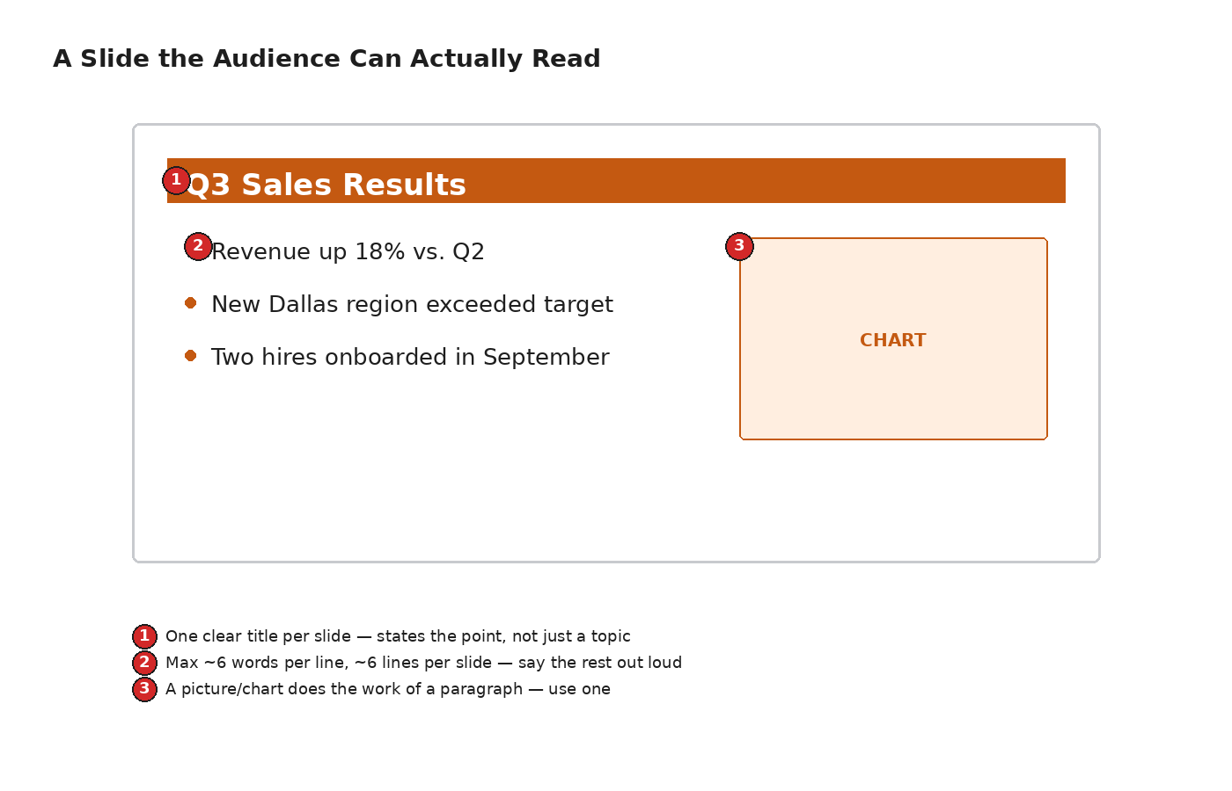
Figure 4.2 — A slide the audience can actually read

Step-by-Step: Build a 5-Slide Portfolio Deck
- Slide 1 (Title): your name and a one-line professional identity, e.g., “Jane Mokoena — Customer Support Specialist.”
- Slide 2 (About Me): 3–4 short bullets on your background and strengths.
- Slide 3 (Skills): a short bulleted list or simple icon row of your key skills.
- Slide 4 (Example of Your Work): a screenshot, chart, or short case study of something you've done, even informally.
- Slide 5 (Contact): your email, phone, and LinkedIn if you have one.
- Apply one Design theme to all 5 slides, then export as a PDF.
✨ TRICK
Select any text box and press Ctrl+Shift+> a few times to bump the font size up quickly — useful for making a title dominate a slide without opening the font-size dropdown.

Common Mistakes
⚠ COMMON MISTAKE
Cramming full sentences and paragraphs onto a slide. Aim for the 6×6 guideline: roughly 6 words per line, 6 lines per slide, maximum — say the rest out loud instead of writing it out.

⚠ COMMON MISTAKE
Stacking multiple transitions and animations on every slide. One consistent, simple transition (or none) looks more confident than a different flashy effect on every slide.

Keyboard Shortcuts
Shortcut | What it does
F5 | Start the slideshow from the beginning
Shift + F5 | Start from the current slide
Esc | Exit the slideshow
Ctrl + M | Insert a new slide
Ctrl + D | Duplicate the selected slide/object
Ctrl + Shift + > / < | Increase / decrease font size
✏️ PRACTICE: Build your portfolio deck
- Create the 5-slide deck described above with your real information.
- Apply a single Design theme across all slides.
- Practice presenting it once using Presenter View.
CHAPTER 5

Microsoft Outlook
Professional email and calendar scheduling

Why It Matters for Your Job Search
Nearly every step of a job search runs through email: applying, scheduling interviews, following up, and eventually accepting an offer. A clear, professional email habit makes every one of those steps go more smoothly.

Tour the Interface
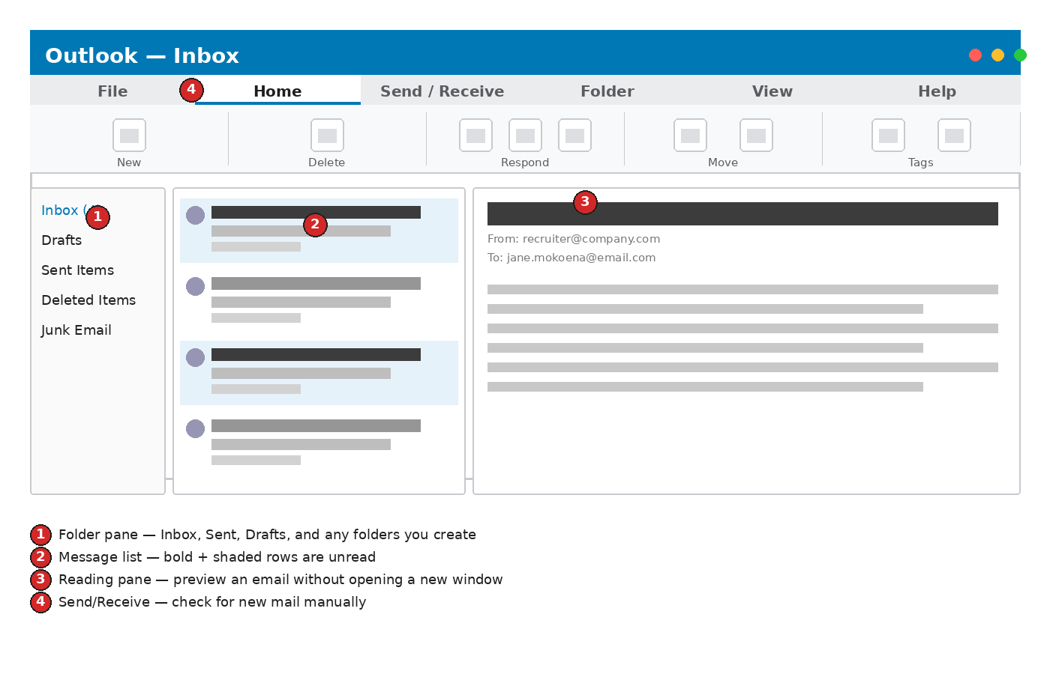
Figure 5.1 — The Outlook interface: folders, message list, reading pane

Core Skills

5.1 Composing an Email
- Click New Email (Home tab, far left).
- Fill in To (and Cc only if genuinely needed — avoid Cc'ing people unnecessarily).
- Write a specific Subject line — vague subjects are more likely to be skipped or caught by spam filters.
- Write the body: a greeting, a short clear purpose, and a polite close with your name and phone number.
- Attach any files (Insert tab > Attach File) before hitting Send — it's the single most common email mistake to forget.
- Click Send.

5.2 Replying & Forwarding
- Reply answers only the original sender; Reply All includes everyone who received the original message — use Reply All only when everyone genuinely needs your response.
- Forward sends the message on to someone new, with the option to add your own note above it.

5.3 Attachments
Keep attachments reasonably sized and clearly named (see Chapter 1's file-naming section). PDF is the safest format for a resume attachment since it can't be accidentally edited and looks identical on any device.

5.4 Signatures
File > Options > Mail > Signatures lets you create a standard block — name, phone, LinkedIn — automatically added to every new email so you never have to retype your contact details.

5.5 Folders & Rules
- Right-click Inbox in the folder pane > New Folder to create folders like “Job Applications” or “Interviews.”
- Drag emails into folders to keep your inbox from becoming overwhelming during an active search.
- Home tab > Rules can automatically move or flag emails matching a pattern, like anything from a specific recruiter's email domain.

5.6 The Calendar
- Switch to Calendar view (bottom-left icons) to see your schedule.
- Click any time slot, or New Event, to add an interview — include the location or video-call link in the event's details so it's easy to find later.
- Set a Reminder (default 15 minutes; change it to something like 1 hour before an interview so you have time to prepare).

Anatomy of a Professional Email
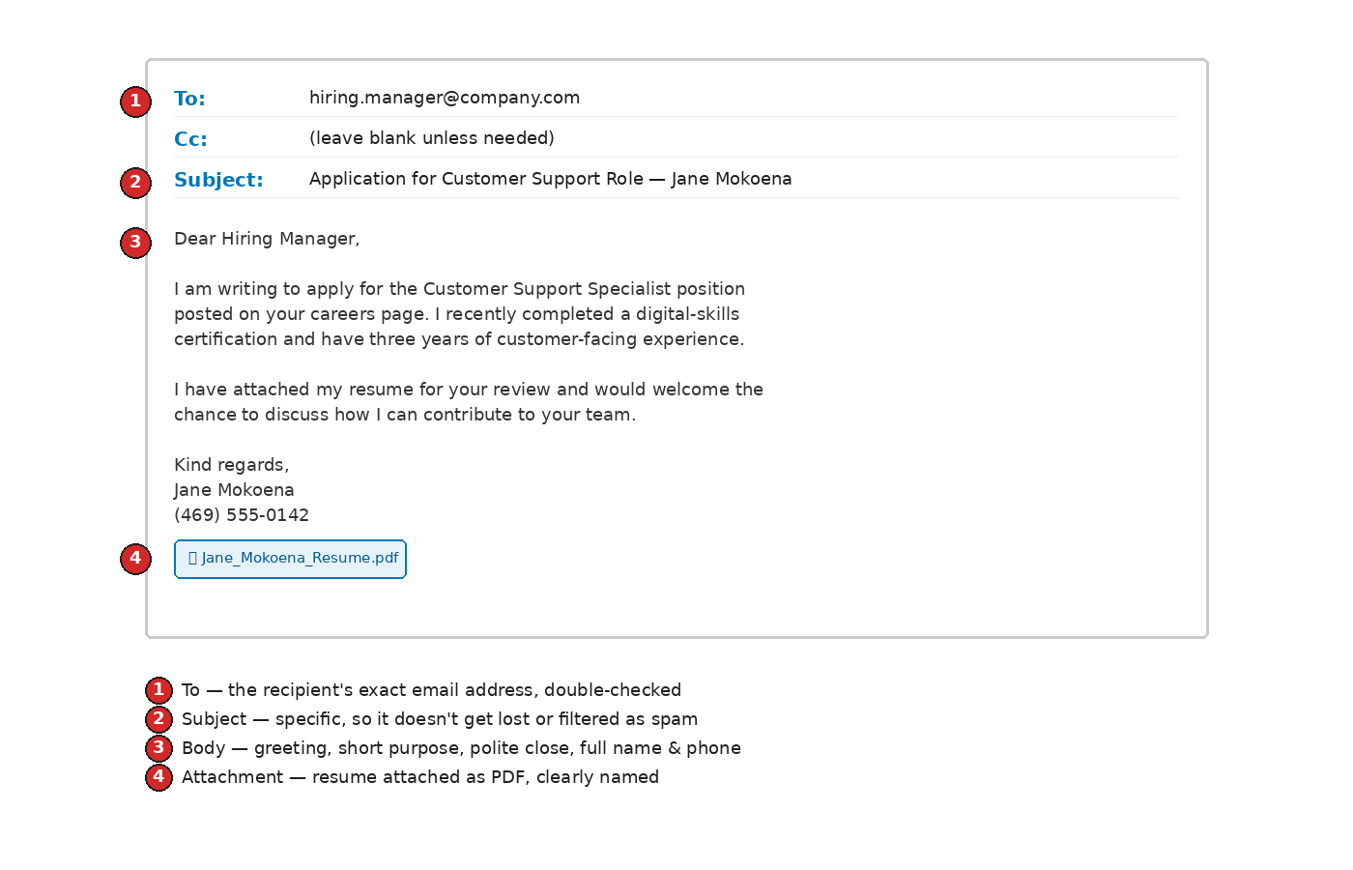
Figure 5.2 — Anatomy of a professional job-application email

Step-by-Step: Send a Job Application Email
- Click New Email.
- Address it to the exact contact or application email given in the job posting — double-check for typos.
- Write a subject like “Application for [Job Title] — [Your Name].”
- Write 2–3 short paragraphs: why you're applying, your most relevant qualification, and a polite close.
- Attach your resume PDF (and cover letter PDF if requested).
- Re-read once before sending — check the recipient address, subject, and that the attachment is actually attached.
✨ TRICK
Forgot the attachment? Outlook can detect words like “attached” in your email body and will warn you before sending if no file is actually attached — don't dismiss that warning without checking.

Common Mistakes
⚠ COMMON MISTAKE
Writing the whole email body first, then forgetting to attach the resume before clicking Send. Attach the file first, before writing the body, so it's never the last step you forget.

⚠ COMMON MISTAKE
Using Reply All on a group thread when only one person needs the reply, or emailing from an unprofessional personal address. Use a simple professional-looking email address (ideally some form of your real name) for all job-search correspondence.

Keyboard Shortcuts
Shortcut | What it does
Ctrl + N | New email
Ctrl + R | Reply
Ctrl + Shift + R | Reply All
Ctrl + Enter | Send the current email
Ctrl + Shift + A | New calendar appointment
✏️ PRACTICE: Send a practice application email
- Set up an email signature with your name and phone number.
- Create a “Job Applications” folder.
- Draft (and send, to yourself or a friend, as practice) a complete application email with your resume attached.

Bonus: Three Email Templates Worth Saving

Following Up on an Application
ℹ NOTE
Subject: Following Up — [Job Title] Application
Hi [Name], I applied for the [Job Title] role on [date] and wanted to follow up to confirm you received my application. I remain very interested in the opportunity and am happy to provide any further information. Thank you for your time. Best, [Your Name]

Thank-You After an Interview
ℹ NOTE
Subject: Thank You — [Job Title] Interview
Hi [Name], Thank you for taking the time to speak with me today about the [Job Title] role. I enjoyed learning more about [something specific discussed] and remain excited about the opportunity to contribute to your team. Please let me know if there's any further information I can provide. Best, [Your Name]

Confirming an Interview Time
ℹ NOTE
Subject: Re: Interview Confirmation — [Job Title]
Hi [Name], Thank you for the invitation. I confirm I'm available on [date] at [time] and will [join the video call at this link / call this number]. Please let me know if you need anything from me beforehand. Best, [Your Name]

Email Etiquette at a Glance
Shortcut | What it does
Respond within | 24–48 hours when possible, even just to acknowledge receipt
Subject lines | Specific and updated — edit the subject when replying if the topic has changed
Tone | Professional but warm; avoid all-caps, excess exclamation points, or slang
Proofread | Read once more before sending — typos in a job-search email stand out
CHAPTER 6

Microsoft Teams
Virtual interviews, networking calls, and remote team meetings

Why It Matters for Your Job Search
Many first-round interviews now happen over video. Being comfortable joining a call, muting/unmuting, and sharing your screen without fumbling helps you focus on the actual conversation instead of the technology.

Tour the Interface
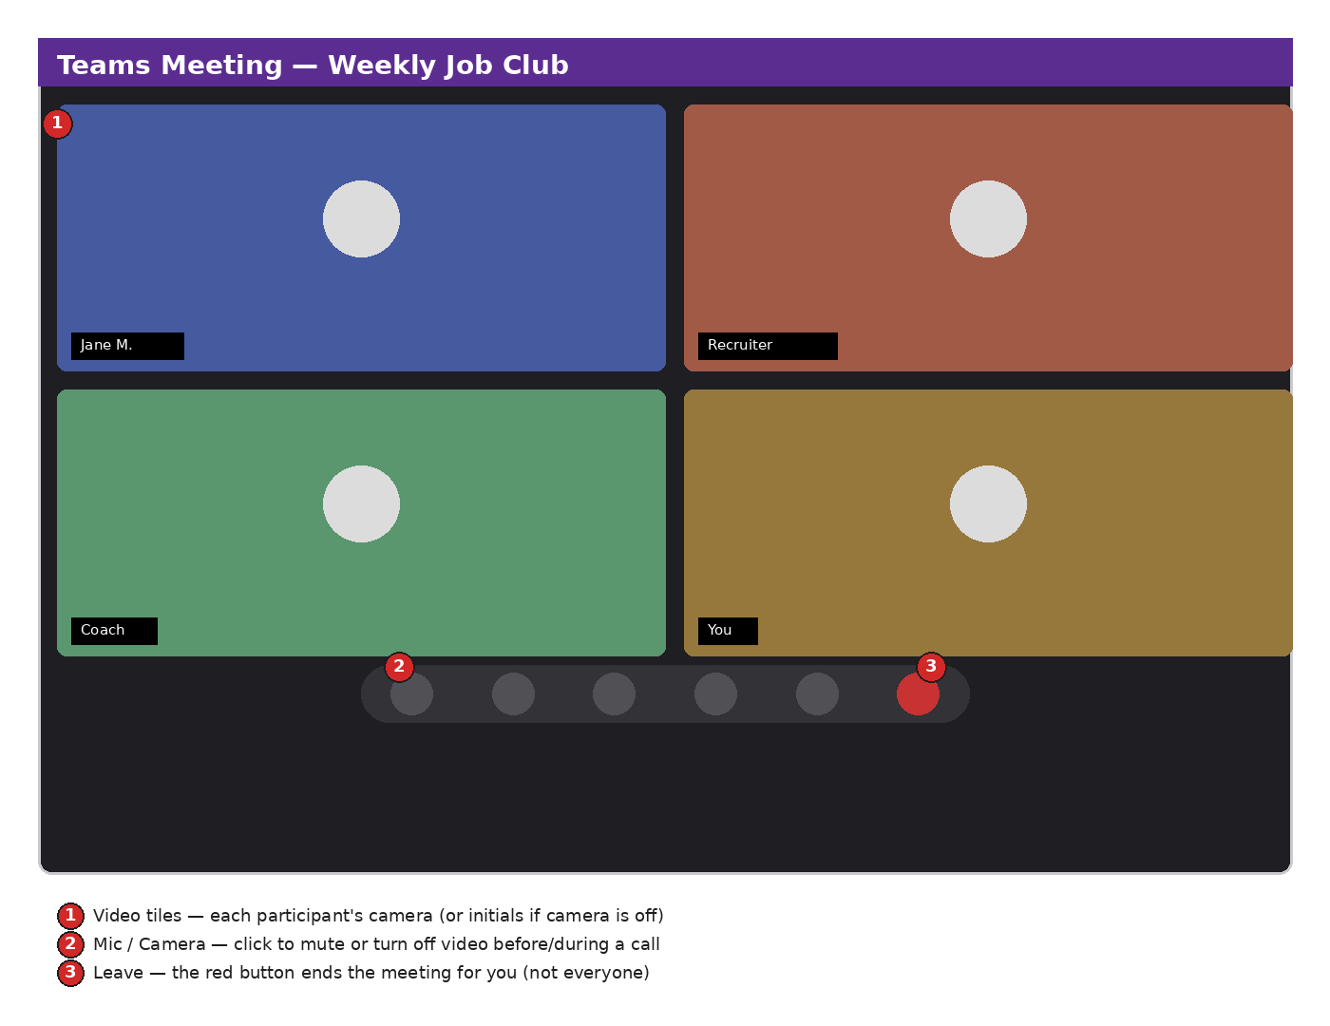
Figure 6.1 — A Teams meeting window

Core Skills

6.1 Joining a Meeting
- Click the meeting link you were sent (in an email or calendar invite) a few minutes before it starts.
- On the join screen, check that your camera and microphone look correct, then click Join now.
- If asked, wait in the Lobby — the meeting organizer will let you in.

6.2 During the Meeting
- Mute/unmute — the microphone icon in the control bar; mute yourself whenever you're not speaking, especially in a group call.
- Camera on/off — the camera icon next to it.
- Chat — a text panel for sharing links or asking a question without interrupting.
- Raise Hand — signals you'd like to speak without talking over someone.
- Share screen — useful for walking an interviewer through a portfolio or document.

6.3 Virtual Backgrounds & Video Setup
Before joining, you can blur your background or choose a plain virtual background from the same pre-join screen — useful if your space isn't camera-ready. For an interview, a blurred real background often looks more natural than an obviously virtual one.

6.4 Teams & Channels (workplace use)
Beyond one-off meetings, Teams also organizes ongoing group work into Teams (a whole department or project) and Channels (a topic within that team) with their own persistent chat and file storage — something you'll likely encounter once hired.

Step-by-Step: Prepare for a Virtual Interview
- The day before, click the meeting link early (it's fine to test-join and leave) to confirm your camera, mic, and internet connection all work.
- Choose a quiet, well-lit spot with a plain or tidy background; blur it if needed.
- Close unrelated browser tabs and apps so notifications don't pop up mid-interview.
- Join 2–3 minutes early, camera on, muted until invited to speak.
- Keep the chat panel open in case the interviewer shares a link there.
💡 TIP
Look at your camera, not the screen, when speaking — it reads as eye contact to the person on the other end, even though it feels a little unnatural at first.

Common Mistakes
⚠ COMMON MISTAKE
Forgetting to unmute before speaking (everyone does this at least once). Get in the habit of glancing at the mic icon before you start talking.

⚠ COMMON MISTAKE
Joining from a noisy or poorly-lit location for an important call. A quiet room and a light source in front of you (not behind you) make a bigger difference to how you come across than any virtual background.
✏️ PRACTICE: Test your setup
- Start a test meeting with a friend or family member (or use Teams' built-in “test call” feature) to check your audio and video.
- Practice muting, unmuting, and sharing your screen once each.
- Try a blurred background and see how it looks on camera.

Bonus: Chat & Channels for Ongoing Work
Once you're hired, most of your day-to-day Teams use won't be scheduled video calls — it'll be Chat (quick one-to-one or small-group messages, similar to texting) and Channels (organized, topic-based conversations visible to a whole team, with their own file storage). Getting comfortable with both before you need them for a job removes one more unfamiliar tool from your first week.

Meeting Etiquette Checklist
Shortcut | What it does
Before | Test your camera/mic; join 2–3 minutes early; silence your phone
During | Stay muted when not speaking; use Raise Hand instead of interrupting
Camera | On for interviews and small meetings unless told otherwise
After | Follow up by email if you promised to send something during the call
CHAPTER 7

OneDrive & OneNote
Cloud storage and note-taking that keep your job search organized

Why It Matters for Your Job Search
OneDrive keeps every version of your resume, cover letters, and trackers safely backed up and accessible from any device — no more emailing files to yourself. OneNote gives you one organized place for interview notes, company research, and questions to ask, instead of scattered scraps of paper.

OneDrive
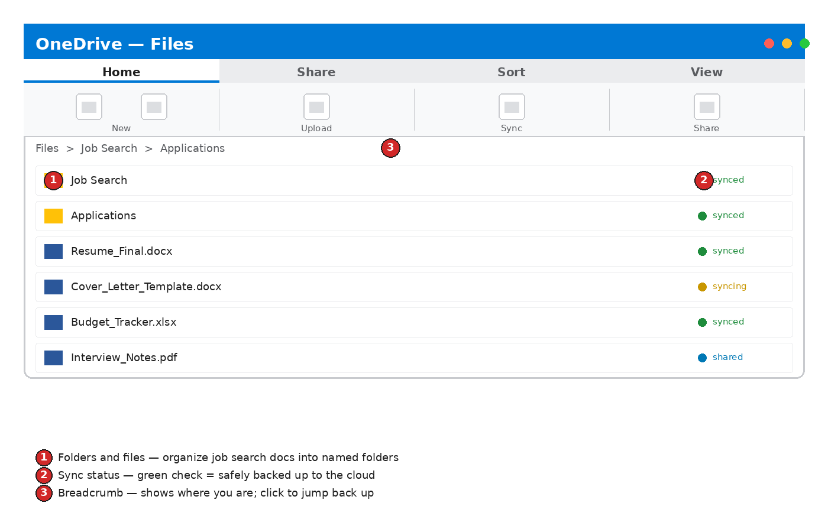
Figure 7.1 — OneDrive file browser

7.1 Uploading & Organizing Files
- Click + New to create a folder, or Upload to add existing files from your computer.
- Organize with folders the way you would on a physical desk: a “Job Search” folder containing “Applications,” “Resumes,” and “Interview Prep” subfolders keeps everything findable.
- The colored dot next to each file's sync status tells you at a glance whether it's safely backed up (green), still uploading (yellow), or shared with someone (blue).

7.2 Sharing a File
- Right-click the file (or select it and click Share).
- Choose whether the link lets people View only or Edit — View only is usually safest for a resume you're sending out.
- Copy the link, or enter the recipient's email directly.

7.3 Accessing Files Anywhere
Install the free OneDrive app on your phone to view or share your resume from anywhere — useful if an interviewer asks for it on the spot, or you need to fill out an application from your phone.

OneNote
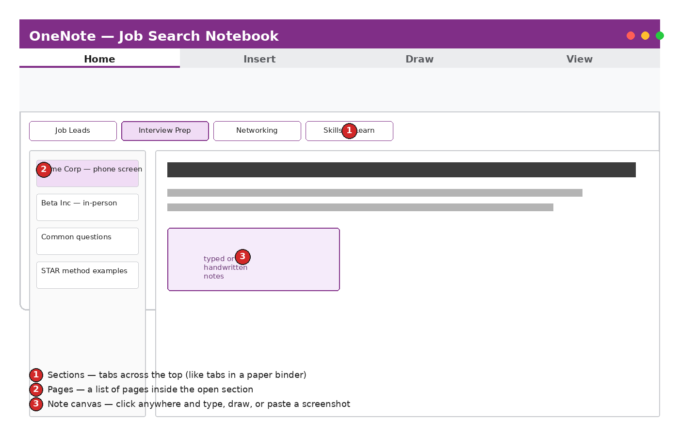
Figure 7.2 — A OneNote notebook

7.4 Notebooks, Sections & Pages
- A Notebook (e.g., “Job Search”) is the top-level container.
- Sections are the tabs across the top — group by topic, like “Job Leads,” “Interview Prep,” “Networking.”
- Pages are individual notes inside a section — one page per company or per interview works well.

7.5 Taking Notes
Click anywhere on the page and start typing — unlike Word, OneNote doesn't require a rigid top-to-bottom layout; you can click and type in any empty spot on the page, paste in a screenshot of a job posting, or even draw with a mouse or touchscreen.

Step-by-Step: Set Up Your Job Search System
- In OneDrive, create a “Job Search” folder with subfolders: Resumes, Cover Letters, Applications.
- Move (or save new copies of) the resume and cover letter you built in Chapter 2 into the right subfolders.
- Create a OneNote notebook called “Job Search.”
- Add sections: Job Leads, Interview Prep, Common Questions & Answers, Companies to Research.
- Add one page per upcoming interview with the company name, key facts you've researched, and questions you want to ask.
✨ TRICK
In OneNote, press Ctrl+Alt+1 through Ctrl+Alt+5 to instantly apply Heading styles the same way you would in Word — handy for keeping company-research pages organized and skimmable.

Common Mistakes
⚠ COMMON MISTAKE
Saving important files only to the computer's local Desktop, with nothing backed up. If that computer is lost, stolen, or breaks, everything on it goes with it. Save straight into OneDrive so it's backed up automatically.
✏️ PRACTICE: Set up your system
- Build the OneDrive folder structure and OneNote notebook described above.
- Move your Chapter 2 resume into the correct OneDrive folder.
- Share your resume folder (View only) with a friend or mentor for feedback.
CHAPTER 8

Your Digital Job Search Toolkit
Bringing every chapter together into one working system
If you've worked through each chapter, you now have the beginnings of a complete, professional job-search toolkit. Use this checklist to confirm what's in place, and to know what to tackle next.

Toolkit Checklist
- ☐ A one-page resume built in Word and saved as a PDF (Chapter 2)
- ☐ A cover letter template you can adapt for each application (Chapter 2 skills applied)
- ☐ A job application tracker in Excel with conditional formatting (Chapter 3)
- ☐ A short portfolio/“About Me” deck in PowerPoint (Chapter 4)
- ☐ A professional email signature and a “Job Applications” folder in Outlook (Chapter 5)
- ☐ A tested camera/microphone setup and at least one practice video call in Teams (Chapter 6)
- ☐ An organized OneDrive folder structure, backed up automatically (Chapter 7)
- ☐ A OneNote notebook for interview prep and company research (Chapter 7)

A Simple 30-Day Practice Plan
Shortcut | What it does
Week 1 | Build your resume (Word) and job tracker (Excel); set up OneDrive folders
Week 2 | Write your cover letter template; set up your Outlook signature and folders
Week 3 | Build your portfolio deck (PowerPoint); set up your OneNote notebook
Week 4 | Test a Teams call; apply what you've built to 3–5 real applications

Where to Get More Help
- Microsoft's own free help center: support.microsoft.com — searchable, step-by-step articles for every app in this book.
- Press F1 inside any Office app to open that app's built-in Help pane.
- LinkedIn Learning and YouTube both have free video walkthroughs if you learn better by watching than reading.
ℹ NOTE
Skills fade if they aren't used. Try to touch each of these apps at least once a week, even after your job search ends — Office 365 skills are near-universal in office jobs, and staying comfortable with them keeps you ready for whatever comes next.

Your 30-Day Action Plan (Fill This In)
Use this worksheet to turn the plan above into your own commitments. Print it, or type directly into this table.
Week | My goal this week | Done? / Notes
Week 1
Week 2
Week 3
Week 4

Appendix A: Keyboard Shortcuts Cheat Sheet

Works in Every Office App
Shortcut | What it does
Ctrl + S | Save
Ctrl + Z / Y | Undo / Redo
Ctrl + C / X / V | Copy / Cut / Paste
Ctrl + A | Select all
Ctrl + F | Find
Ctrl + P | Print
Alt + Tab | Switch between open windows

Word
Shortcut | What it does
Ctrl + B / I / U | Bold / Italic / Underline
Ctrl + Shift + C / V | Copy / apply formatting only (Format Painter)
Ctrl + Home / End | Jump to start / end of document

Excel
Shortcut | What it does
Ctrl + ; | Insert today's date
Alt + = | AutoSum
F2 | Edit active cell
Ctrl + Arrow key | Jump to edge of data block

PowerPoint
Shortcut | What it does
F5 / Shift + F5 | Present from start / from current slide
Ctrl + M | New slide
Esc | Exit presentation mode

Outlook
Shortcut | What it does
Ctrl + N | New email
Ctrl + R / Shift + R | Reply / Reply All
Ctrl + Enter | Send

Appendix B: Glossary of Terms
Cloud storage | Files saved on remote servers (like OneDrive) instead of only on your own computer, so they're backed up and accessible from anywhere.
Ribbon | The strip of tabs and buttons across the top of every Office app.
Formula | An instruction in Excel, always starting with =, that calculates a result.
Cell | A single box in an Excel grid, identified by its column letter and row number (e.g., B3).
Template | A pre-designed starting document, spreadsheet, or slide deck you can customize.
Attachment | A file included with an email, separate from the email's typed message.
Sync | The process of automatically keeping a file identical between your device and the cloud.
PDF | A fixed file format that looks the same on any device, commonly used for finished resumes.
Muting | Turning off your microphone during a video call so others can't hear your side.
Notebook / Section / Page | OneNote's three levels of organization, from broadest (Notebook) to most specific (Page).
Ribbon tab | One of the labeled headings (Home, Insert, Layout...) across the top of the ribbon; clicking one swaps the buttons shown below it.
Placeholder | A pre-formatted box on a PowerPoint slide (for a title, text, or image) that disappears once you click in and start typing.
Conditional formatting | An Excel feature that automatically changes a cell's color or style based on its value.
Signature (email) | A block of text — usually name, phone, title — automatically added to the end of every new email you send.
Reading pane | The panel in Outlook that previews a selected email's contents without opening it in a separate window.
Channel | A topic-based conversation space inside a Microsoft Teams Team, with its own chat history and files.
Version history | A record of previous saved versions of a file, letting you view or restore an earlier copy if something goes wrong.
Function (Excel) | A named, built-in calculation (like SUM or IF) used inside a formula.
Autofill | Dragging a cell's fill handle to automatically continue a pattern (numbers, dates, formulas) down a column or across a row.

Appendix C: Troubleshooting Common Problems

My document/spreadsheet won't save.
Check your internet connection if the file lives in OneDrive. Try File > Save As to save a fresh copy locally as a backup, then re-open OneDrive once connected.

I can't find a file I know I saved.
Use the search bar at the top of File Explorer, OneDrive, or inside the Office app's File > Open > Recent list. Files saved to OneDrive can also be found by signing into office.com from any device.

A formula shows #REF!, #DIV/0!, or #NAME?
#REF! means a cell the formula pointed to was deleted; #DIV/0! means it's dividing by zero or an empty cell; #NAME? usually means a typo in a function name. Click the cell and read the formula bar to see exactly what it's doing.

My video/audio isn't working in Teams.
Before joining, use the pre-join screen's camera/mic preview. If nothing shows, check that no other app (like Zoom) is already using the camera, and check your device's privacy settings allow Teams to access camera/microphone.

My document looks different on someone else's computer.
This is usually a font issue — the other computer doesn't have the same font installed, so Word substitutes another. Save and send a PDF instead, which locks the exact appearance.

I accidentally deleted something important.
Press Ctrl+Z immediately in most apps to undo. In OneDrive, check the Recycle Bin (left-hand menu) — deleted files sit there for a period before being permanently removed.

I'm not sure if my file actually saved.
Look for “Saved” or “AutoSave: On” near the top of the window. If it says “Saved to this device only,” consider moving the file to OneDrive so it's backed up automatically.

Someone I shared a file with says they can't open it.
Check the sharing permissions (right-click the file > Share > check access) — they may need the link re-sent, or may need a Microsoft account to view it depending on your organization's settings.

My email isn't sending or receiving.
Check your internet connection first. In Outlook, the Send/Receive tab has a manual “Send/Receive All Folders” button that forces a refresh.

I can't remember which app to use for a task.
Revisit the “Quick Reference: Which App Do I Use For...?” table near the front of this book.

